**Problem Statement :**

**Title: EMERGING FOREST FIRES. COLLETHODS FOR EARLY DETECTION Of Forest Fire - IBM-Project-29170-1660121813**

Forest fires are occurring throughout the year with an increasing intensity in the summer

and autumn periods.

To fight forest fires, different solution where employed throughout the years. Forest fires also considered as a main contributed to the air pollution, due to the fact that during every fire huge amounts of gases and particle mater are released in the atmosphere.

The simplest of these solution is the establishment of a network of observation posts - both cheap and easy to accomplish, but also time-consuming for the involved people.

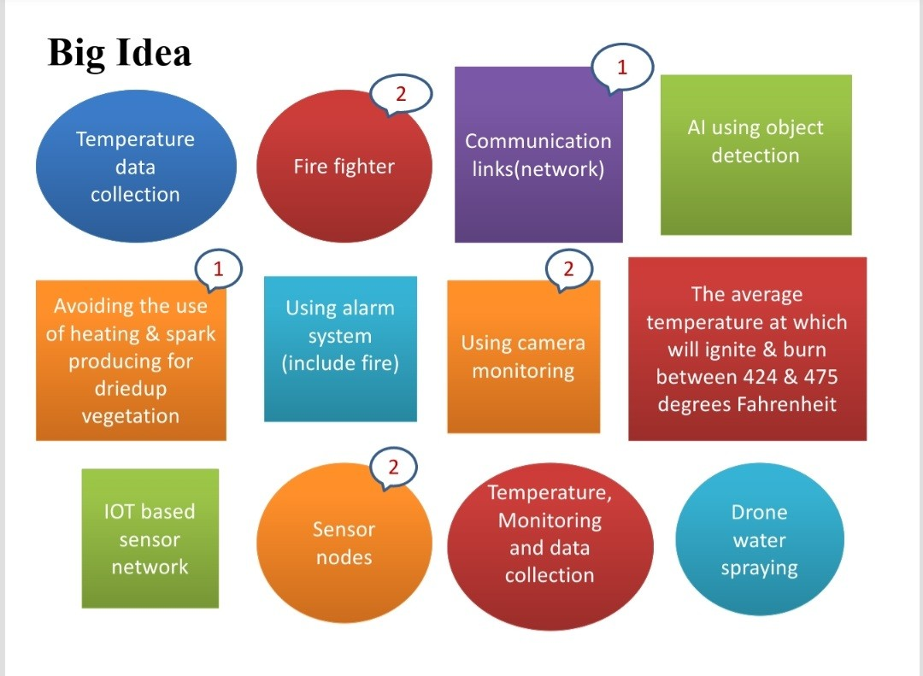

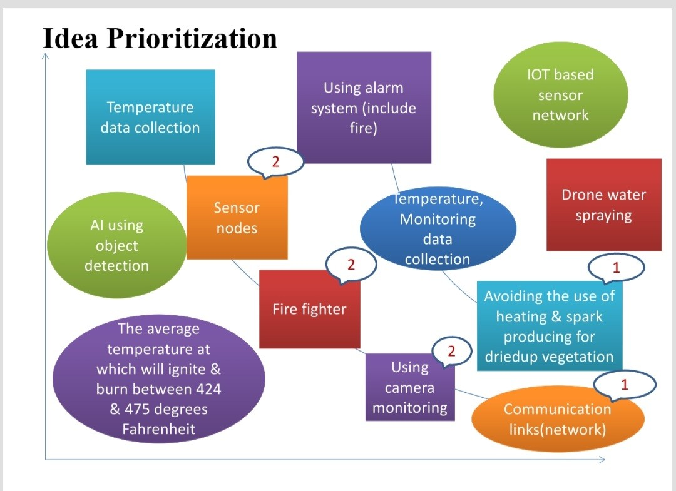

High

Low

Low

High

I M P O R T A N T

FEASIBILITY